**PROJECT REPORT ON**

**MICRO, SMALL, MEDIUM ENTERPRISES IN INDIA**

**Submitted to**



DEPT. OF COMPUTER SCIENCE & ENGINEERING

SCHOOL OF APPLIED SCIENCE,

Centurion University of Technology & Management Odisha

in partial fulfilment of the requirement for award of the degree of

Bachelor of Computer Application

in

Data Visualisation using Python

**Submitted By:**

JOYJEET JENA 220714100038

Under the Guidance of

Sabyasachi Mohanty

**CERTIFICATE**



This is to be certified that the project entitled “MICRO, SMALL, MEDIUM ENTERPRISES IN INDIA” has been submitted for the in partial fulfilment of the requirement for award of the degree of Bachelor of Computer Application in Data Visualisation using Python, CUTM, Jatni during the academic year 2022-2023 is a persuasive piece of project work carried out by Joyjeet Jena under the guidance of “Sabyasachi Mohanty” and no part there has been submitted by them for any degree to the best of my knowledge.

Signature of HOD Signature of Project Guide

Mr. Rakesh Ray Sabyasachi Mohanty

**EVALUATION SHEET**

* Title of the Project: “MICRO, SMALL, MEDIUM ENTERPRISES IN INDIA”
* Year of submission: 2022-2023
* Name of the degree: BCA
* Student Name with Regn No:
* JOYJEET JENA (220714100038)
* Name of the Guide: Sabyasachi Mohanty
* Result: [APPROVED/REJECTED]

Signature of HOD Signature of Project Guide

Mr. Rakesh Ray Sabyasachi Mohanty

Signature of External Examiner

**CANDIDATE’S DECLARATION**

I, JOYJEET JENA (220714100038), CUTM, Jatni, hereby declare that the Project Report entitled “MICRO, SMALL, MEDIUM ENTERPRISES IN INDIA” is an original work and data provided in the study is authentic one. This report has not been submitted to any other Institute for the award of any other degree by me.

Signature of Students

JOYJEET JENA (220714100038)

**ACKNOWLEDGEMENT**

It is my pleasure to be indebted to various people, who directly or indirectly contributed in the development of this work and who influenced our thinking, behaviour and acts during the course of study.

We also extend our sincere appreciation to Mr. Rakesh Ray who provided his valuable suggestions and precious time in accomplishing our project report.

We express our sincere gratitude to Prof. (Dr.) Prashant Mohanty, Dean Academics for providing academic support & opportunities.

We express our sincere gratitude to Sabyasachi Mohanty, Project guide for providing academic support & opportunities.

We also extend our sincere appreciation to Abhijit Pal, Coordinator who provided his valuable suggestions and precious time in accomplishing our project report.

Lastly, we would like to thank the almighty and our parent for their moral support and friends with whom we shared my day-to day experiences and received lots of suggestions those improved the quality of work.

STUDENT NAME:

JOYJEET JENA (220714100038)

**ABSTRACT**

Micro, Small and Medium Enterprises constitute the backbone of an economy in maintaining an appreciable growth rate and in generating employment opportunities. This sector has been regarded as engine of economic growth and social development in many developed and developing countries. Contribution of MSMEs to the Indian economy in terms of employment generation, containing regional disparities, fostering equitable economic growth and enhancing export potential of the country has been quite phenomenal. Despite some infrastructural deficiencies and challenges like flow of institutional credit and inadequate market linkages, this sector has registered remarkable success with regard to increase in number, quantum of investment, scale of production and overall contribution to national GDP. The study makes an attempt to focus on the huge growth potential and opportunities available in India for development of MSME sector, to identify important issues and challenges and offer suggestions to address the same.

**CONTENTS**

|  |  |
| --- | --- |
| TITLE | PAGE NO. |
| Acknowledgement | 5 |
| Abstract | 6 |
| Introduction | 8 |
| Objective of the Project | 8 |
| Software Requirements | 9 |
| Library Requirements | 9 |
| Introduction Of MSME’s | 10-20 |
| Source Code | 21-26 |
| Result Analysis | 27 |
| Conclusion | 27 |
| References | 27 |

**INTRODUCTION**

Micro, small and medium enterprises (MSMEs) in India and abroad have demonstrated considerable strength and resilience in maintaining a consistent rate of growth and employment generation during the global recession and economic slowdown. Indian economy during the recent years has shown an appreciable growth performance by contributing to creation of livelihood opportunities to millions of people, in enhancing the export potential and in increasing the overall economic growth of the country. Prompt and appropriate fiscal stimulus, effective monetary policy and huge capital inflows were greatly instrumental in the bounce back situation of the economy. As a catalyst for socio-economic transformation of the country, the MSME sector is extremely crucial in addressing the national objectives of bridging the rural-urban divide, reducing poverty and generating employment to the teeming millions. It is therefore, essential that India adopts a suitable policy framework that provides the required impetus to seize the opportunities and create an enabling business environment in order to keep the momentum of growth and holistic development. It is equally important that the MSME sector must address the infrastructural deficiencies and is well empowered to meet the emerging challenges for its sustainable growth and survival in a globally competitive order.

**OBJECTIVE OF THE STUDY**

The objectives of this study are to briefly highlight on the functional scenario of micro, small and medium enterprises in India, to focus on the huge growth potential and opportunities available for development of this sector, to identify some important issues, challenges and constraints confronted by these enterprises and to offer suggestions to overcome the same.

**SOFTWARE REQUIREMENTS**

* Python 3.10.9
* Vs Code
* Anaconda
* Jupyter Notebook
* OS: Windows 10 or More
* Word Processor: Ms-Office or Libre Office

**LIBRARY REQUIREMENTS**

* NumPy
* Pandas
* Matplotlib
* Seaborn
* Dash
* BS4

**DEFINATION OF MICRO, SMALL AND MEDIUM ENTERPRISES.**

In accordance with the provision of Micro, Small & Medium Enterprises Development (MSMED) Act, 2006 the Micro, Small and Medium Enterprises (MSME) are classified as below:

(i) a micro enterprise, where the investment in plant and machinery or equipment does not exceed one crore rupees and turnover does not exceed five crore rupees.

(ii) a small enterprise, where the investment in plant and machinery or equipment does not exceed ten crore rupees and turnover does not exceed fifty crore rupees.

(iii) a medium enterprise, where the investment in plant and machinery or equipment does not exceed fifty crore rupees and turnover does not exceed two hundred and fifty crore rupees.

(iv)The new classification has come into effect from 1st July, 2020. The earlier criterion of classification of MSMEs under MSMED Act, 2006 was based on investment in plant and machinery / equipment. It was different for manufacturing and services units. It was also very low in terms of financial limits. Since then, the economy has undergone significant changes. a revision in MSME criteria of classification was announced in the Aatmnirbhar Bharat package on 13th May, 2020. This has been done in order to be realistic with time and to establish an objective system of classification and to provide ease of doing business.

(v) As a result, a new composite criterion of classification for manufacturing and service units has been notified on 26.06.2020, with guidelines regarding composite criteria to facilitate the present and prospective entrepreneurs. Now, there will be no difference between manufacturing and service sectors. It has also been decided that the turnover with respect to exports will not be counted in the limits of turnover for any category of MSME units whether micro, small or medium. This is yet another step towards ease of doing business. This will help in attracting investments and creating more jobs.

(vi) The primary responsibility of promotion and development of MSMEs is of the State Governments. However, the Government of India, supplements efforts of the State Governments through various initiatives.

**ORGANISATIONAL STRUCTURE**

The Ministry of MSME consists of Small & Medium Enterprises (SME) Division, Agro &Rural Industry (ARI) Division, Administration & Financial Institutions (AFI), Integrated Finance (IF) Wing and Data Analytics and Technical Co-ordination (DATC) Wing, besides the Office

of the Development Commissioner (DCMSME) as an attached office and other subordinate organisations. The organisational structure of the Ministry is depicted in the following: -

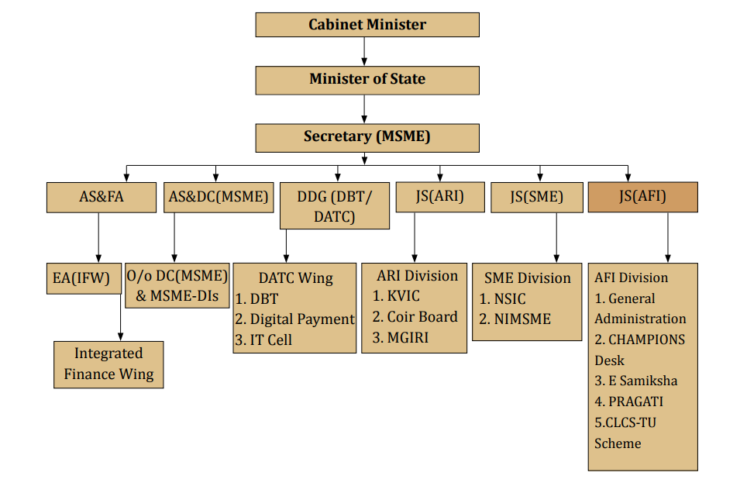

**RECENT DEVELOPMENTS**

Udyam Registration: This Ministry, vide notification has notified a composite criterion of classification of MSMEs based on investment in plant & Machinery/equipment and turnover of MSMEs. A total number of 5,37,677 enterprises have registered under Manufacturing category whereas 8,65,058 enterprises registered under Service sector.

• The Top 5 Industrial sectors of registrations are – Food Products, Textile, Apparel, Fabricated Metal products and Machinery & equipment.

• Registration without PAN is permitted upto 31.03.2021 as a transitional arrangement.

• Similarly, Registration without GST number is also permitted upto 31.03.2021 as a transitional arrangement.

MSME Databank: For facilitating the promotion and development and enhancing the competitiveness of MSMEs, all MSMEs are to furnish information relating to their enterprises online to the Central Government in the data bank maintained by it at www.msmedatabank.in. This data bank will enable Ministry of MSME to streamline and monitor the schemes and pass on the benefits directly to MSMEs. It will also provide the real-time information about the status of MSMEs under various parameters.

**SOME OF THE OTHER RECENT DEVLOPMENTS ARE: -**

* MyMSME
* Direct Benefit Transfer in the M/oMSME
* Digital Payments
* Grievance Monitoring
* Skill Training Eco-system of Minister of MSME

**OVERVIEW AND PERFORMANCE OF THE MSME SECTOR**

**Role of MSME in Indian Economy**

The Micro, Small & Medium Enterprises (MSMEs) have been contributing significantly to the expansion of entrepreneurial endeavours through business innovations. The MSMEs are widening their domain across sectors of the economy, producing diverse range of products and services to meet demands of domestic as well as global markets. As per the data available with Central Statistics Office (CSO), M/o Statistics & Programme Implementation, the contribution of MSME sector in Country’s Gross Value Added (GVA) and Gross Domestic Product (GDP) at current prices from 2014-15 to 2018-19 is as below:

|  |  |  |  |  |  |  |
| --- | --- | --- | --- | --- | --- | --- |
| **Figures in Rs. Crores adjusted for FISIM at current prices** | | | | | | |
| **Year** | **Total MSME GVA** | **Growth (%)** | **Total GVA** | **Share of MSME in GVA (%)** | **All India GDP** | **Share of MSME in All India GDP (in %)** |
| 2014-15 | 3658196 | - | 11504279 | 31.80 | 12467959 | 29.34 |
| 2015-16 | 4059660 | 10.97 | 12574499 | 32.28 | 13771874 | 29.48 |
| 2016-17 | 4502129 | 10.90 | 13965200 | 32.24 | 15391669 | 29.25 |
| 2017-18 | 5086493 | 12.98 | 15513122 | 32.79 | 17098304 | 29.75 |
| 2018-19 | 5741765 | 12.88 | 17139962 | 33.50 | 18971237 | 30.27 |

**ESTIMATE NUMBER OF MSMEs IN COUNTRY**

The MSMEs in India are playing a crucial role by providing large employment opportunities at comparatively lower capital cost than large industries as well as through industrialization of rural & backward areas, inter alia, reducing regional imbalances, assuring more equitable distribution of national income and wealth. As per the National Sample Survey (NSS) 73rd round, conducted by National Sample Survey Office, Ministry of Statistics & Programme Implementation during the period 2015-16, there were 633.88 lakh unincorporated non- agriculture MSMEs in the country engaged in different economic activities.

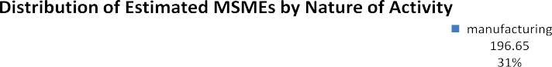

**DISTRIBUTION OF ENTERPRISES (RURAL AND URBAN AREA WISE)**

Micro sector with 630.52 lakh estimated enterprises accounts for more than 99% of total estimated number of MSMEs. Small sector with 3.31 lakh and medium sector with 0.05 lakh estimated MSMEs accounted for 0.52% and 0.01% of total estimated MSMEs, respectively. Out of 633.88 estimated number of MSMEs, 324.88 lakh MSMEs (51.25%) are in rural area and 309 lakh MSMEs (48.75%) are in the urban areas.

|  |  |  |  |  |  |
| --- | --- | --- | --- | --- | --- |
| **Sector** | **Micro** | **Small** | **Medium** | **Total** | **Share (%)** |
| (1) | **(2)** | **(3)** | **(4)** | **(5)** | **(6)** |
| **Rural** | 324.09 | 0.78 | 0.01 | 324.88 | 51 |
| **Urban** | 306.43 | 2.53 | 0.04 | 309.00 | 49 |
| **All** | **630.52** | **3.31** | **0.05** | **633.88** | **100** |

**EMPLOYMENT BY THE MSME’S**

As per the National Sample Survey (NSS) 73rd round conducted during the period 2015-16, MSME sector has been creating 11.10 crore jobs (360.41 lakh in Manufacturing, 0.07 lakh in Non-captive Electricity Generation and Transmission, 387.18 lakh in Trade and 362.82 lakh in Other Services) in the rural and the urban areas across the country. Figure shows the distribution of MSMEs activity wise.

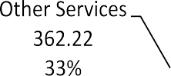

|  |  |  |  |  |
| --- | --- | --- | --- | --- |
| **Broad Activity Category** | **Employment (in lakh)** | | | **Share (%)** |
| **Rural** | **Urban** | **Total** |
| **(1)** | (2) | (3) | (4) | (5) |
| **Manufacturing** | 186.56 | 173.86 | 360.41 | 32 |
| **Electricity\*** | 0.06 | 0.02 | 0.07 | 0 |
| **Trade** | 160.64 | 226.54 | 387.18 | 35 |
| **Other Services** | 150.53 | 211.69 | 362.22 | 33 |
| **All** | **497.78** | **612.10** | **1109.89** | **100** |

**STATE – WISE DISTRIBUTION OF ESTIMATED MSMEs**

State of Uttar Pradesh had the largest number of estimated MSMEs with a share of 14.20% of MSMEs in the country. Top 10 States accounted for a share of 74.05% of the total estimated number of MSMEs in the country. Figure shows the distribution of estimated enterprises in top ten States.

|  |  |  |  |
| --- | --- | --- | --- |
| **Sl. No.** | **State/UT** | **Estimate Number of MSMEs** | |
| **Number (in lakh)** | **Share (in %)** |
| **1** | Uttar Pradesh | 89.99 | 14 |
| **2** | West Bengal | 88.67 | 14 |
| **3** | Tamil Nadu | 49.48 | 8 |
| **4** | Maharashtra | 47.78 | 8 |
| **5** | Karnataka | 38.34 | 6 |
| **6** | Bihar | 34.46 | 5 |
| **7** | Andhra Pradesh | 33.87 | 5 |
| **8** | Gujarat | 33.16 | 5 |
| **9** | Rajasthan | 26.87 | 4 |
| **10** | Madhya Pradesh | 26.74 | 4 |
| **11** | Total Of Above Ten States | 469.36 | 74 |
| **12** | Other States/ UTs | 164.52 | 26 |
| **13** | All | 633.88 | 100 |

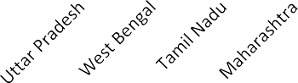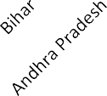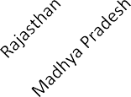

**KHADI SECTOR IN INDIA**

Khadi activity is considered as potential tool for creation of employment opportunities at the doorstep of rural Artisans at very low capital investment. Immediately after independence, Khadi and Village Industries productivity became the grand symbol of nationalism. As such, Khadi came to be known not just a piece of cloth, but as a symbol of freedom and self-reliance.

KVIC is a Statutory Organisation tasked with the role of promoting the production and sale of Khadi. Over 2737 Khadi Institutions form the vast network are implementing the programmes of KVIC in India. Over 4.97 Lakh people are engaged in this activity. Out of which, over 80 percent are women Artisans.

Khadi is the unique programme of KVIC and a potent tool for creation of employment at the Artisans’ doorstep being implemented by Khadi Institutions.

Khadi sector production and sales have grown during previous year. Production and sale of Khadi sector during last 4 years and current year 2020-21 (up to December, 2020) & anticipated up to 31.03.2021 are given below: -

##### Khadi Sector: Production & Sales

**(Rs. in Crore)**

|  |  |  |
| --- | --- | --- |
| **YEAR** | **PRODUCTION** | **SALES** |
| 2016 - 17 | 1520.83 | 2146.60 |
| 2017 - 18 | 1626.66 | 2510.21 |
| 2018 - 19 | 1963.30 | 3215.13 |
| 2019 - 20 | 2324.24 | 4211.26 |
| 2020 - 21 (up to 31 - 12 - 2020) | 1344.69 | 1877.19 |
| 2020 - 21 **(Projected up to 31 - 03 – 2021)** | 2104.01 | 3856.50 |

##### Khadi Sector: Employment

**(Artisan in Lakh)**

|  |  |
| --- | --- |
| **Year** | **Employment** |
| 2016 - 17 | 4.56 |
| 2017 - 18 | 4.65 |
| 2018 - 19 | 4.96 |
| 2019 - 20 | 4.97 |
| 2020 - 21 (up to 31 - 12 - 2020) | 4.97 |
| 2020 - 21 **(Projected up to 31 - 03 - 2021)** | 5.00 |

**VILLAGE INDUSTRIES:**

Village Industries have growth over the previous years. Production and sales of Village Industries Products during last 4 years and current year 2020-2021 & anticipated are given below:-

VILLAGE INDUSTRIES: PRODUCTION & SALES

(Rs. In crore)

|  |  |  |
| --- | --- | --- |
| **YEAR** | **PRODUCTION** | **SALES** |
| 2016 – 17 | 41110.26 | 49991.61 |
| 2017 – 18 | 46454.75 | 56672.22 |
| 2018 – 19 | 56167.04 | 71076.96 |
| 2019 – 20 | 65343.07 | 84664.28 |
| 2020 - 21 (up to 31 - 12 - 2020) | 53705.04 | 70459.28 |
| 2020 - 21 (Projected up to 31 - 03 - 2021) | 76582.43 | 101306.87 |

Village Industries employments during the last the 4 years and current year 2020-21 upto December 2020 and anticipated upto 31.03.2021 are given below:

VILLAGE INDUSTRIES : EMPLOYMENT

**(Artisan in Lakh)**

|  |  |
| --- | --- |
| **YEAR** | **EMPLOYMENT** |
| 2016 – 17 | 131.84 |
| 2017 – 18 | 135.71 |
| 2018 – 19 | 142.03 |
| 2019 – 20 | 147.76 |
| 2020 - 21 (up to 31 - 12 - 2020) | 150.31 |
| 2020 - 21 (Projected up to 31 - 03 - 2021) | 154.12 |

**BUDGETARY SUPPORT TO KVIC: -**

The Ministry of (MSME) provides funds to KVIC for undertaking its various activities. These funds are provided primarily by way of Grants and KVIC in turn re-allocates fund to States Offices, its implementing agencies, namely the State KVIBs, Institutions registered under the Societies Registration Act.

The details of funds provided from Budgetary Sources (both under Plan and Non-Plan head) during the last four years and those earmarked in the Budget Estimate 2020 - 21 are given in the following Table :-

##### BUDGETARY SUPPORT TO KVIC

**(Rs. in Crore)**

|  |  |  |  |  |
| --- | --- | --- | --- | --- |
| **YEAR** | **REVISED ESTIMATE (RE)** | | **FUND RECEIVED FROM MINISTRY** | |
| **PLAN** | **NON- PLAN** | **PLAN** | **NON- PLAN** |
| 2016 - 17 | 1647.40 | 285.35 | 1591.08 | 285.35 |
| 2017 - 18 | 2395.08 | - | 2130.57 | - |
| 2018 - 19 | 3085.78 | - | 3200.65 | - |
| 2019 - 20 | 3461.70 | - | 3453.78 | - |
| 2020 - 21 | 2072.91 | - | 1508.89  (up to 05.01.2021 | - |

THE NATIONAL SMALL INDUSTRIES CORPORATION (NSIC) LIMITED:

The National Small Industries Corporation Ltd. (NSIC) is an ISO 9001-2015 certified Government of India Enterprise under Ministry of Micro, Small and Medium Enterprises (MSME). NSIC has been working to promote aid and foster the growth of micro, small and medium enterprises in the country.

The mission of NSIC is “To promote and support Micro, Small and Medium Enterprises by providing integrated support services encompassing, Marketing, Finance, Technology and other Services.”.

The vision of NSIC is “To be premier organization fostering the growth of Micro, Small and Medium Enterprises in the country.”

**BUDGETARY SUPPORT TO MGIRI**

The Union Government through Ministry of MSME provides funds to MGIRI for undertaking its various activities. The details of funds provided to MGIRI during the last four years and current financial year is as under:

##### (Rs. in crore)

|  |  |  |
| --- | --- | --- |
| **Year** | **Budget allocation (RE)** | **Funds released** |
| 2016-17 | 10.15 | 9.42 |
| 2017-18 | 10.00 | 7.80 |
| 2018-19 | 10.00 | 8.89 |
| 2019-20 | 10.00 | 10.0 |
| 2020-21 | 7.28 | 5.06* |

**Projects Achievement during 2020-21(Rs. in lakh)**

|  |  |  |  |
| --- | --- | --- | --- |
|  | **Final Approval** | **Project Cost** | **Proposed GoI grant** |
| **Common Facility Centres (CFCs)** | 14 | 17799.16 | 12834.70 |
| **Infrastructure Development (ID) Projects** | 18 | 12607.70 | 7685.68 |
| **Total** | **32** | **30406.86** | **20520.38** |
|  |  |  |  |

**INTERNATIONAL COOPERATION:**

Worldwide, the MSMEs have been accepted as the engine of economic growth for promoting equitable development. Similarly, in India also, MSMEs have played an important role in export promotion of the country. However, the progression of COVID-19 virus across the globe from beginning of the year 2020 brought in ample problems for trade and many other sectors of the economy. To maintain its niche in the international and global markets, MSMEs have been required to remain globally competitive and have to continuously update themselves to meet the challenges emerging.

With agility and dynamism, the sector has shown admirable innovation and adaptability in the past. However, MSMEs have been facing great challenges due to the nationwide lockdown that was imposed as a measure to curb the virus. With consistent measures being taken in India to curb the virus and boost MSMEs to sustain the economic climate the future prospects appear to be promising.

Through its various Schemes and programmes, have been providing support to the Indian MSME sector by giving them exposure of the international market; latest technology; sharing of experiences and best management practices in the international arena.

**SOURCE CODE**

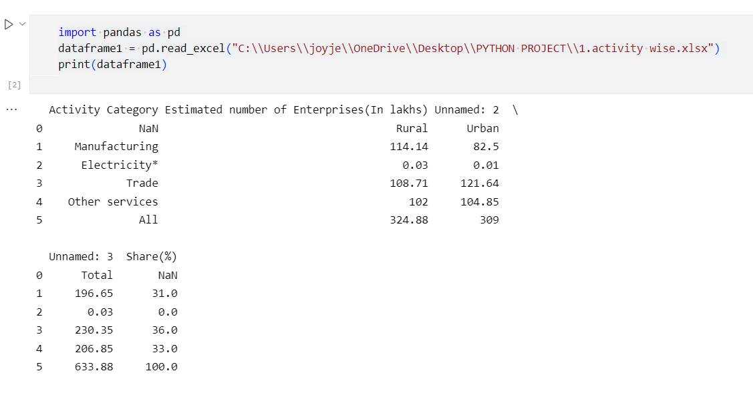

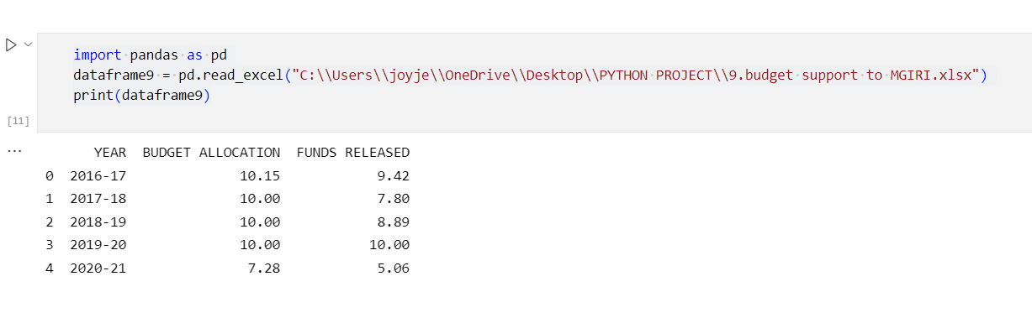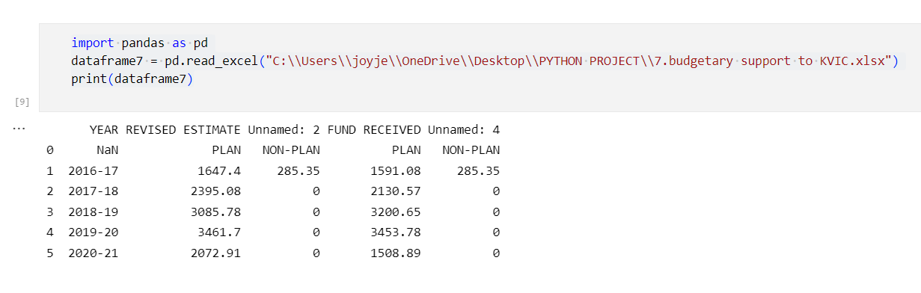

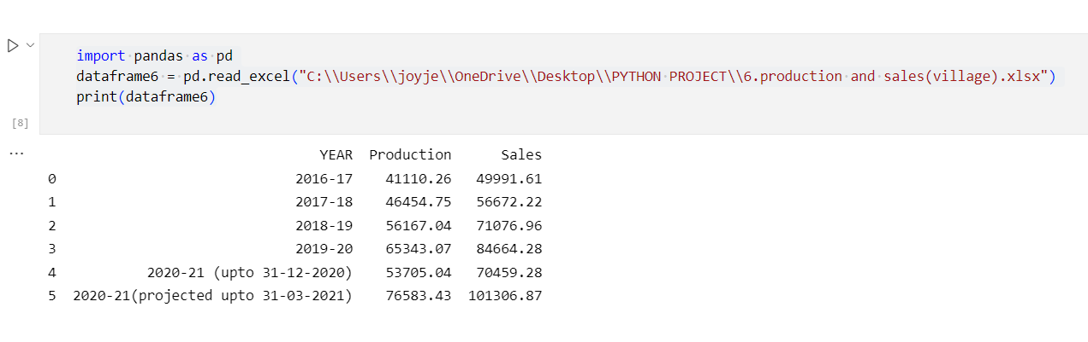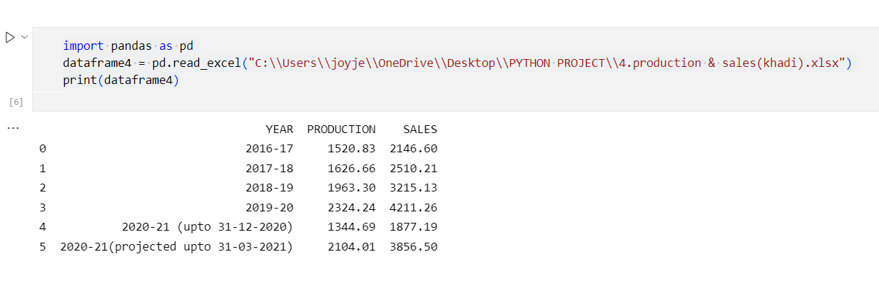

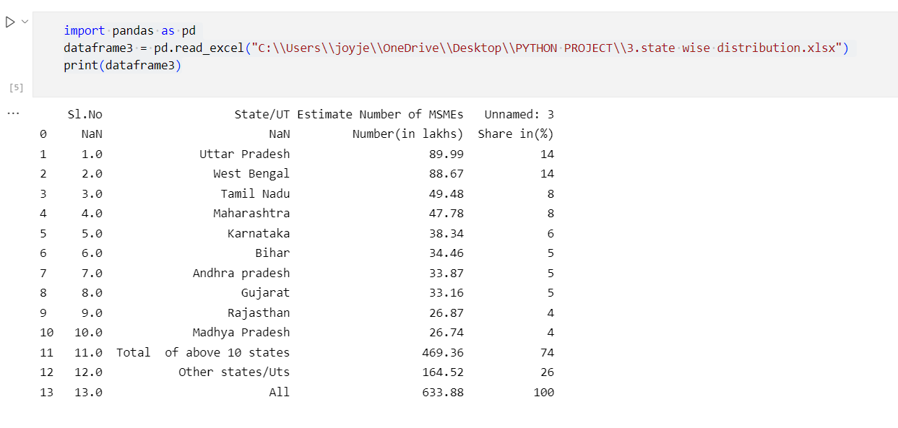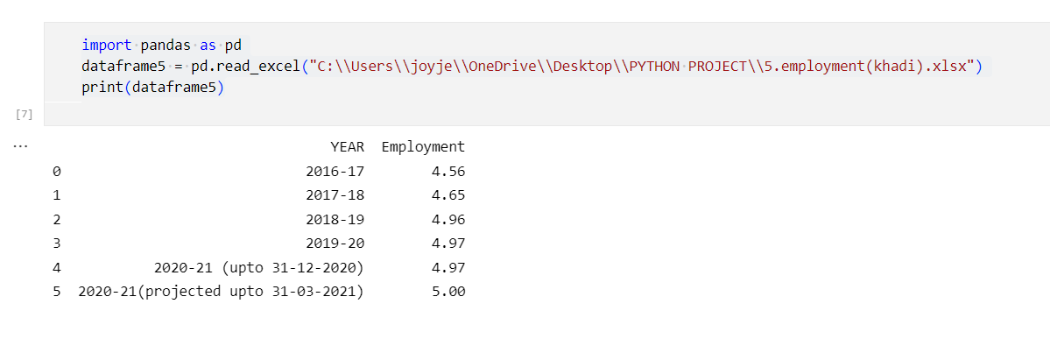

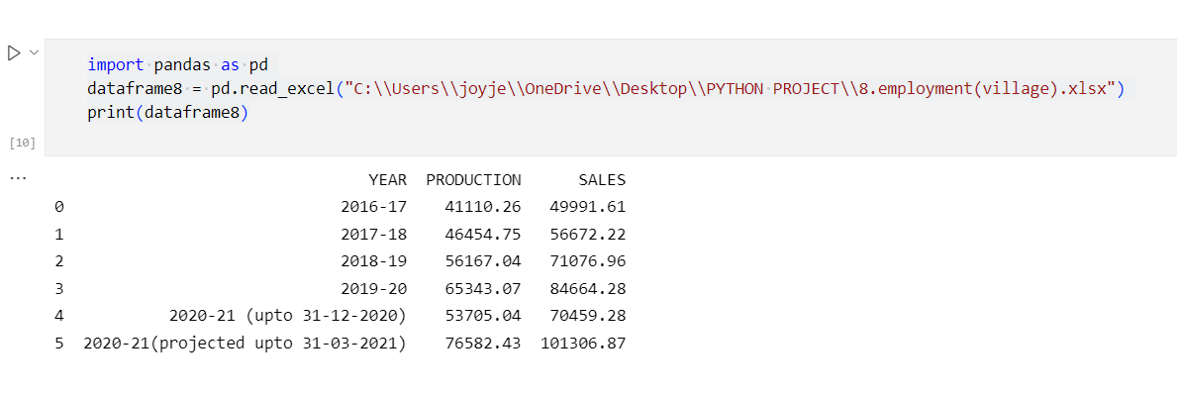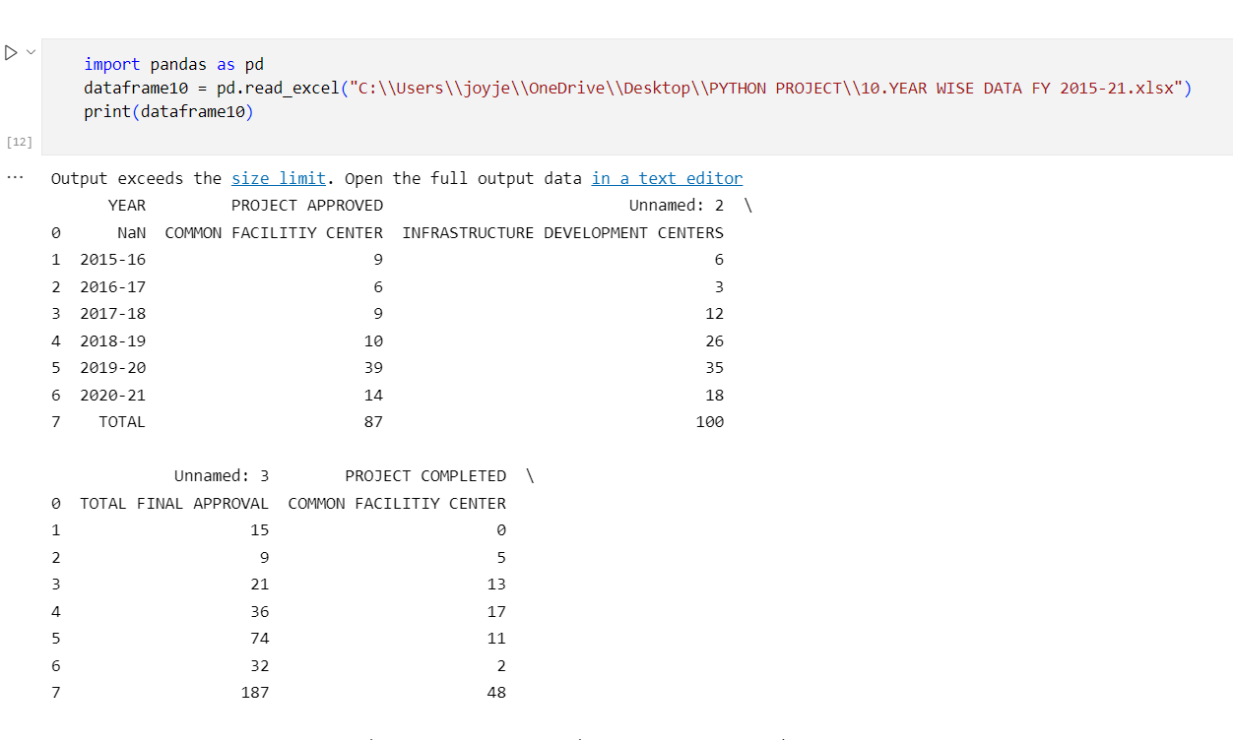

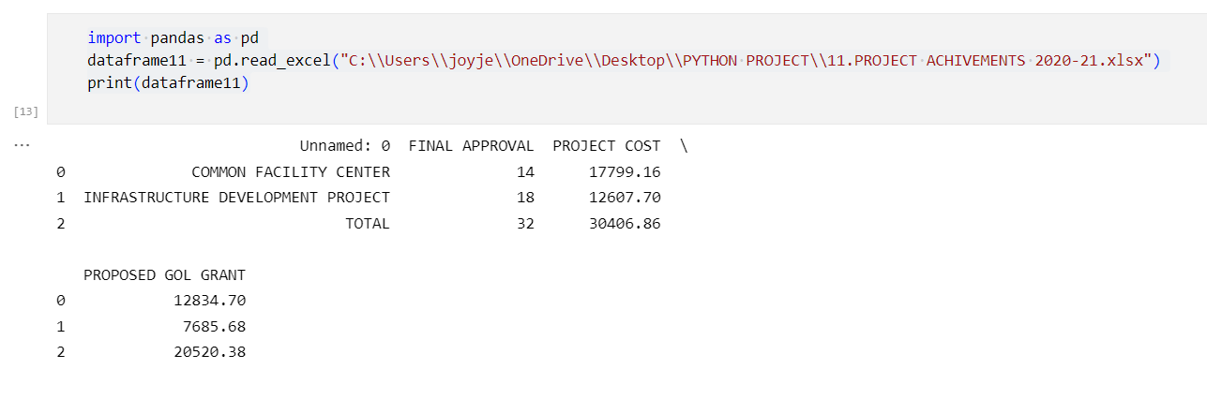

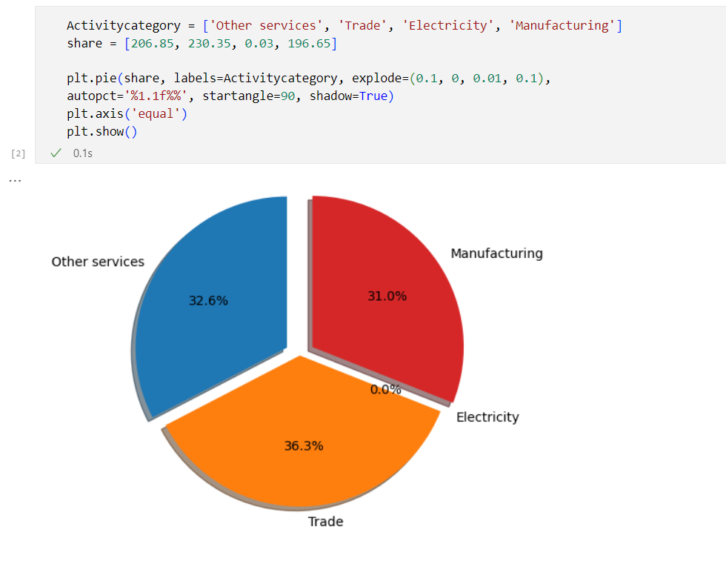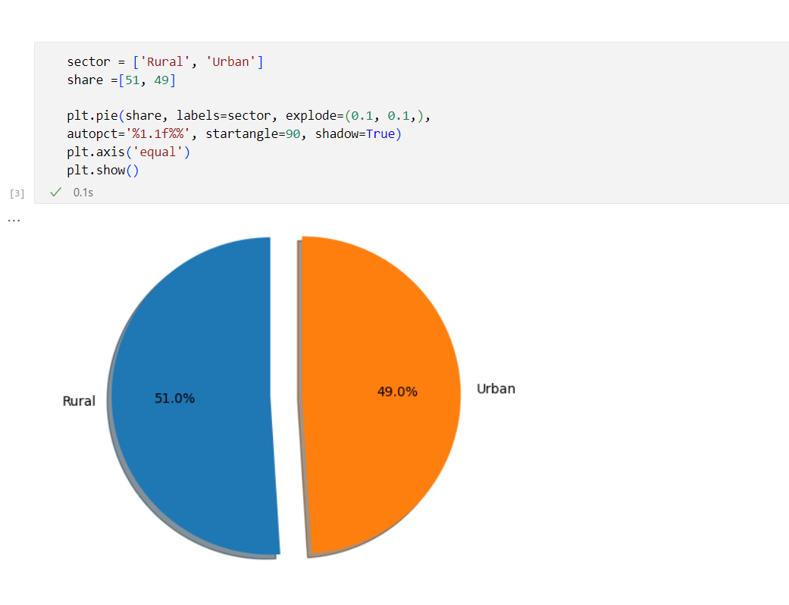

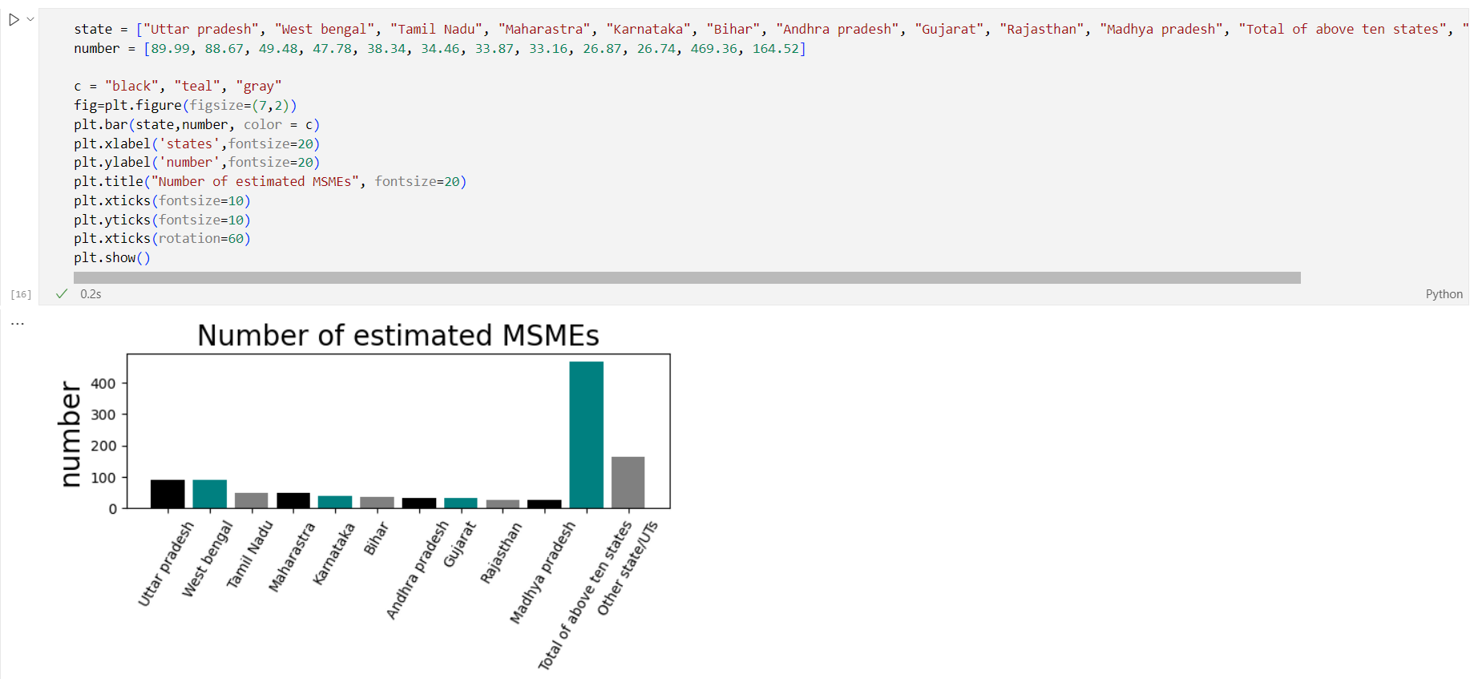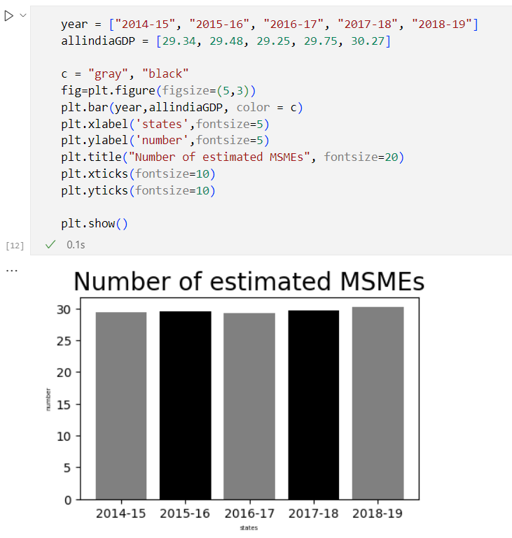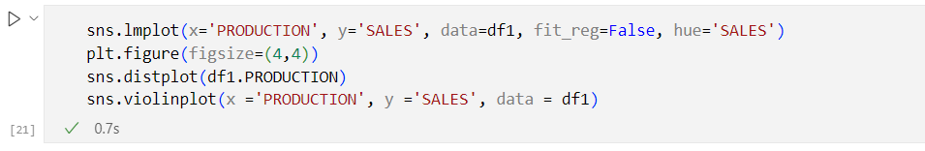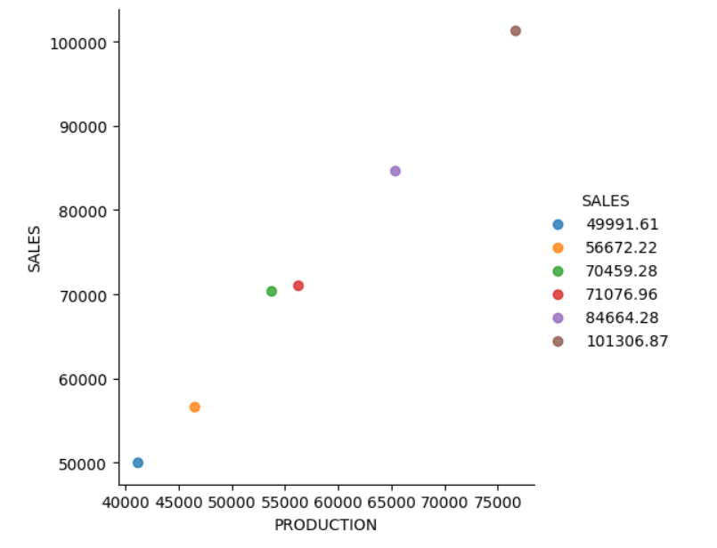

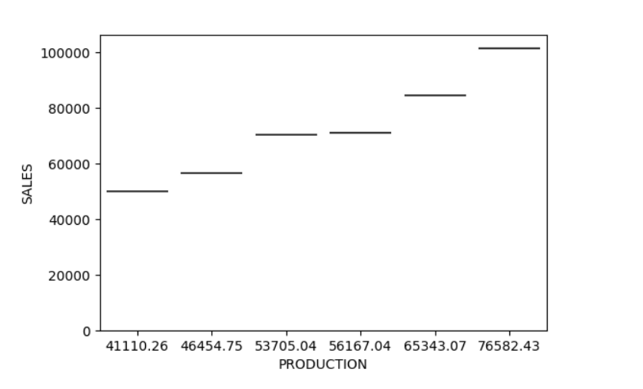

**RESULT ANALYSIS**

* The contribution of a sector to the country's GDP is one of the factors used to assess its success in an economy.
* MSME play an important part in the economy's socioeconomic transformation. MSME employs about 80 million people and operates over 36 million units, accounting for 8% of the country's GDP.
* These businesses are spread over India, with 55 percent of them operating in rural areas and the remainder in semi-urban and metropolitan areas. As a result, MSMEs make a significant contribution to India's balanced economic growth.
* we can observe that manufacturing units account for 67.1 percent of total registered units, while service units account for 16.8 percent of total registered units and repair and maintenance units account for 16.1 percent of total registered units.
* The number of EM-IIs filed climbed from 1.73 lakh in 2007-08 to 1.93, 2.13, 2.38, 2.82, 3.23, 3.63, and 4.25 lakh in 2008-09, 2009-10, 2010-11, 2011-12, 2012-13, 2013-14, and 2014-15.

**CONCLUSION:**

To conclude, the MSME sector of India is today at the gateway of global growth on the strength of competitive and quality product range. However, facilities from the government is required to maximize the transaction costs of technology upgradation, market penetration, modernisation of infrastructure etc.

The MSME sector has often been termed the ‘engine of growth’ for developing economies. We begin with an overview of this sector in India and look at some recent trends which highlights the development and export promotion, reservation policy, tooling & technology, manpower training, technology and managerial skills gave enormous opportunities for growth and better performance in the economy.

It is concluded that MSME’s in the Indian Economy has shown tremendous growth and excellent performance with the contribution of policy frame work and efficient steps which has been taken by the government time to time for the growth and development of the MSME’s.

**REFERENCE**

* <https://en.wikipedia.org/wiki/Ministry_of_Micro,_Small_and_Medium_Enterprises>
* Government of India Annual Report For MSME 2021-2022